[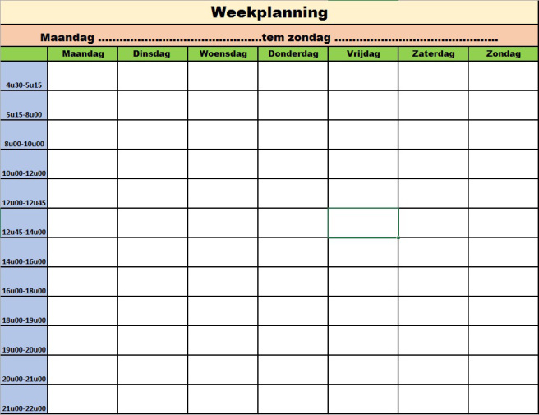](https://www.google.nl/url?sa=i&rct=j&q=&esrc=s&source=images&cd=&cad=rja&uact=8&ved=0ahUKEwil0ODtkfvYAhVN0FMKHULlDCYQjRwIBw&url=https://kokenmeteve.wordpress.com/2016/09/23/een-weekplanning/&psig=AOvVaw2PqicdE95rKoPJgcebkhDg&ust=1517245426196936)